***CSE-326***

*PROJECT*

*FINAL REPORT FILE*

*WEBSITE FOR CODING PRACTICE*



*SECTION: K19VQ*

*YEAR: 2019-2020 (SESSION-2)*

*SUBMITTED TO: MOIN HASAN (25676)*

# Student Declaration

*This is to declare that this report has been written by us. No part of the report is copied from other sources. All information included from other sources has been duly acknowledged. We aver that if any part of the report is found to be copied, we are shall take full responsibility for it.*

MINAKSHI (11918043)

RIYANSH AGRAWAL (11918280)

VARTICA KUSHWAHA (11918283)

BONAFIDE CERTIFICATE

Certified that this project report " **WEBSITE FOR CODING PRACTICE** " is the Bonafide work of " MINAKSHI, RIYANSH AGRAWAL, VARTICA KUSHWAHA”, who carried out the project work under my supervision.

Name of supervisor: MOIN HASAN

UMS ID: 25676

(Department of Admissions)

TEAM MEMBERS:

1. MINAKSHI

* Roll No.: 49
* Reg No.: 11918043

1. RIYANSH AGRAWAL

* Roll No.: 50
* Reg. No.: 11918280

1. VARTICA KUSHWAHA

* Roll No.: 51
* Reg. No.: 11918283

**ROLES & RESPONSIBILITIES**

Team Leader: Riyansh Agrawal

Coder: Riyansh Agrawal/Minakshi

Content: Riyansh Agrawal/Minakshi/ Vartica Kushwaha

Interface Design: Riyansh Agrawal/Minakshi

Visuals: Minakshi/ Vartica Kushwaha

Report Work: Vartica Kushwaha /Riyansh Agrawal/Minakshi

INTRODUCTION

A **coding** **platform** is the environment in which a piece of software is executed. It may be the hardware or the operating system (OS), even a web browser and associated application programming interfaces, or other underlying software, as long as the program **code** is executed with it. A coding platform is the stage on which computer programs can run.

In this project we have created a coding platform for some coding languages like C, C++, JAVA, etc. which includes tutorial of every coding language, compilation and execution of the code. Users can register themselves for maintaining their coding record and to access some hidden features.

Moreover, it also includes subscription facility for special offers and guidance.

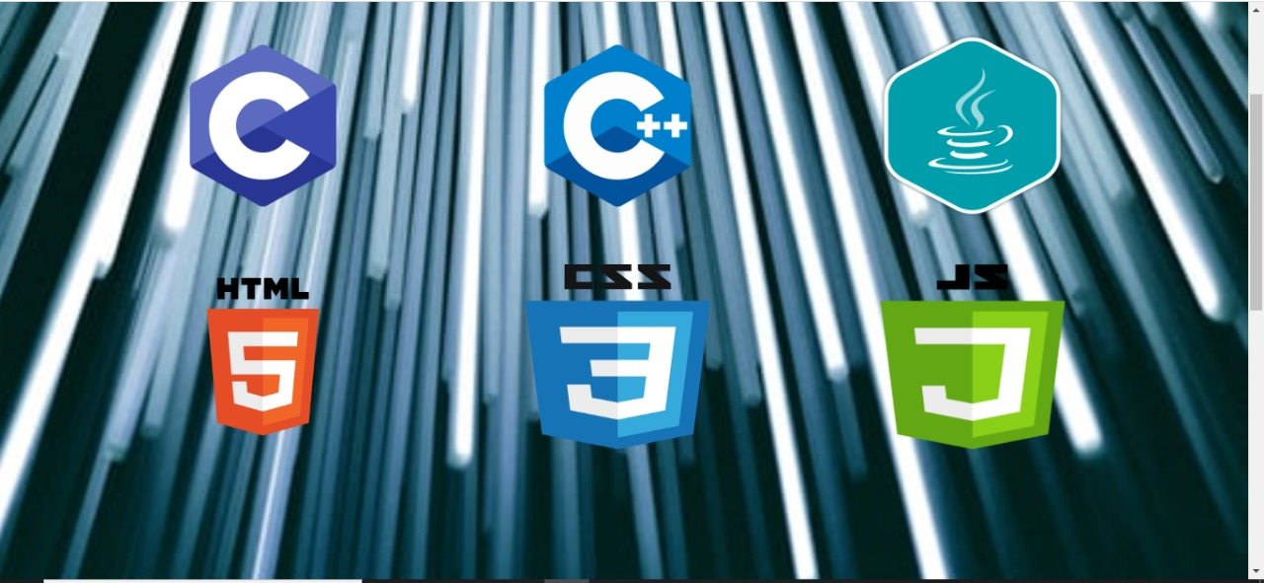

DESCRIPTION

As discussed earlier about the content of this project. So it includes information about the coding languages:

* **C**
* C was originally developed at Bell Labs by Dennis Ritchie between 1972 and 1973 to make utilities running on Unix. Later, it was applied to re-implementing the kernel of the Unix operating system.
* C is the mother of all programing language. It was designed to be compiled using a relatively straightforward compiler to provide low-level access to memory and language constructs that map efficiently to machine instructions, all with minimal runtime support.
* **C++**
* C++ is a high-level, general-purpose programming language created by Bjarne Stroustrup as an extension of the C programming language, or "C with Classes".
* The language has expanded significantly over time, and modern C++ has object-oriented, generic, and functional features in addition to facilities for low-level memory manipulation.
* It is almost always implemented as a compiled language, and many vendors provide C++ compilers, including the Free Software Foundation, LLVM, Microsoft, Intel, Oracle, and IBM, so it is available on many platforms.
* **HTML**
* Hypertext Markup Language (HTML) is the standard markup language for documents designed to be displayed in a web browser.
* It can be assisted by technologies such as Cascading Style Sheets (CSS) and scripting languages such as JavaScript.
* HTML describes the structure of a web page semantically and originally included cues for the appearance of the document.
* **CSS**
* Cascading Style Sheets (CSS) is a style sheet language used for describing the presentation of a document written in a markup language like HTML.
* CSS is a cornerstone technology of the World Wide Web, alongside HTML and JavaScript.
* CSS is designed to enable the separation of presentation and content, including layout, colors, and fonts & can improve content accessibility, provide more flexibility and control in the specification of presentation characteristics.
* **JAVA**
* Java is a general-purpose programming language that is class-based, object-oriented, and designed to have as few implementation dependencies as possible.
* The syntax of Java is similar to C and C++, but it has fewer low-level facilities than either of them.
* As of 2019, Java was one of the most popular programming languages in use according to GitHub.
* **JAVASCRIPT**
* JavaScript often abbreviated as JS, is a programming language that conforms to the ECMAScript specification.
* JavaScript is high-level, often just-in-time compiled, and multi-paradigm.
* Alongside HTML and CSS, JavaScript is one of the core technologies of the World Wide Web.

IMPLIMENTATION AND WORKING OF PROJECT

HOW THE WEBSITE LOOKS LIKE:

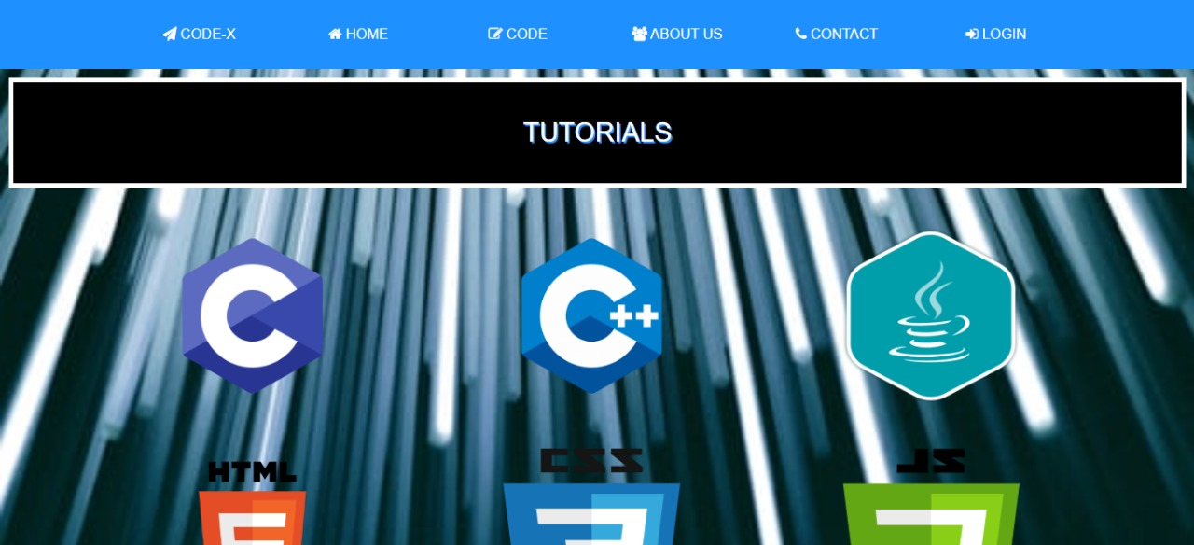

This is how the coding platform “CODEX” looks like, as the name with icon is visible at the top left in menu bar. User has many options of programming language, as explained in the description section. Also, the tutorials for all the languages is here for convenience of user.

TUTORIALS:



Tutorials for all the coding languages are provided at the main page so that if user have any doubt or problem regarding the particular language, they can clear it. Just by clicking on the respective coding language, a new page will open with all the topics with explanations, examples and practice questions of the language.

Tutorial for “C”:

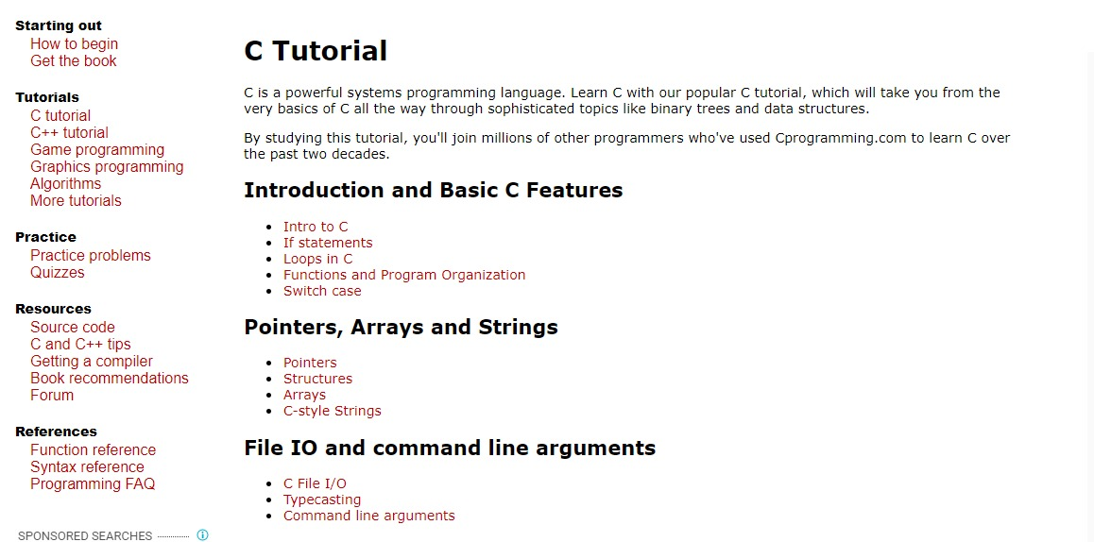

Tutorial for “C++”:

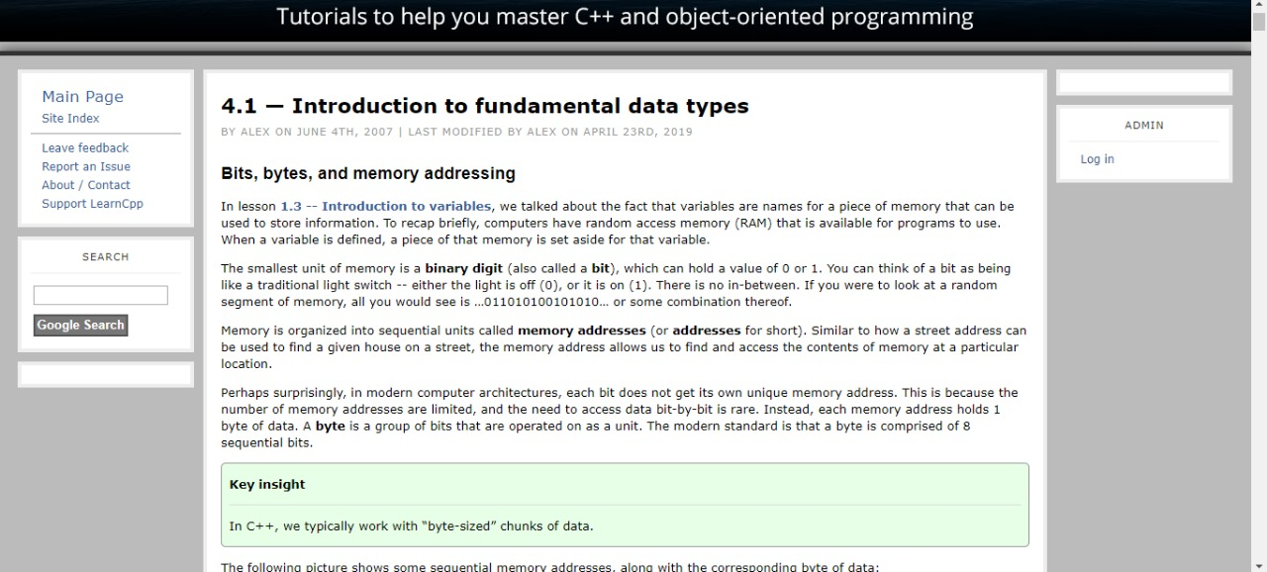

Tutorial for “CSS”:

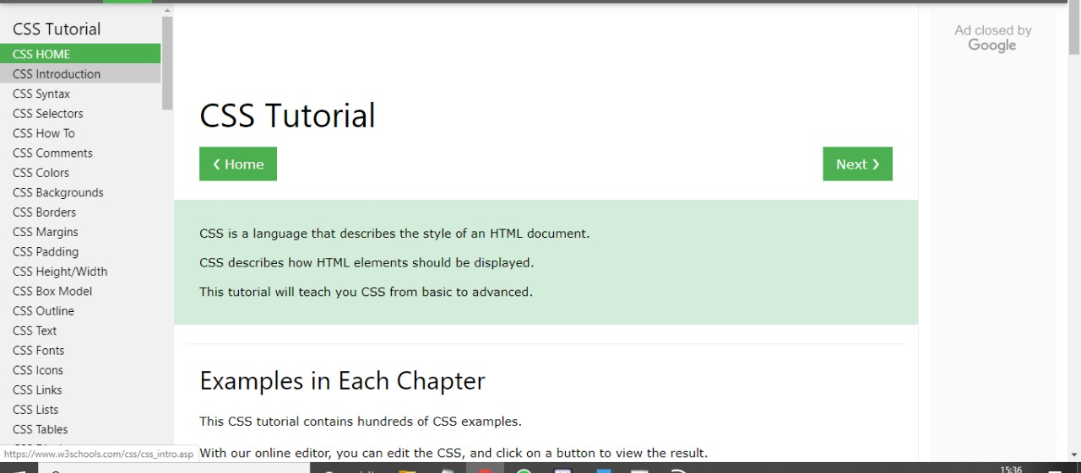

Tutorial for “JAVA”:

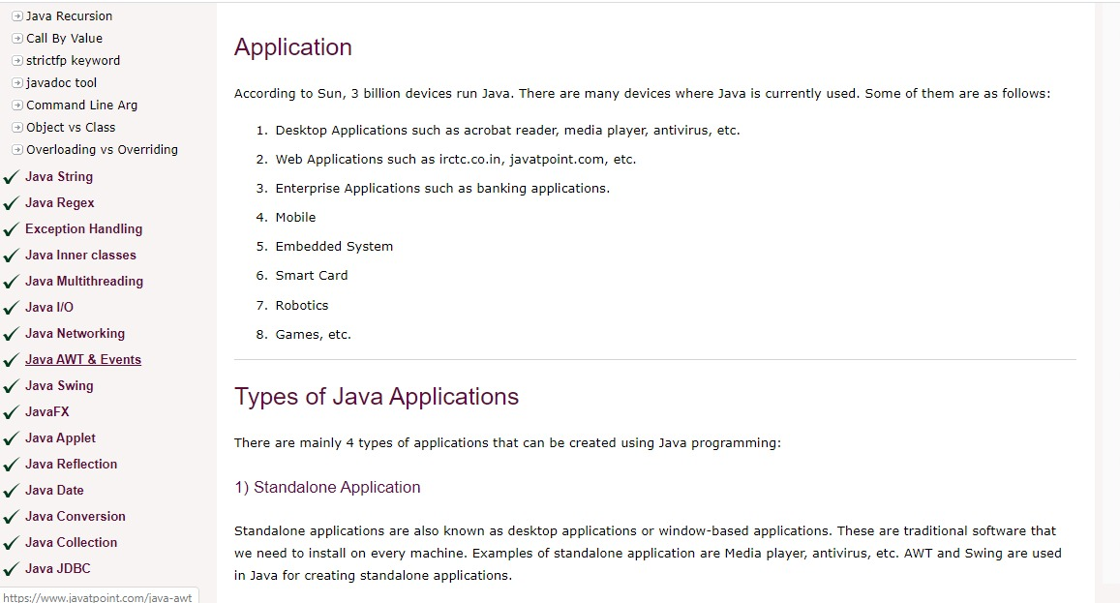

Tutorial for “JAVASCRIPT”:

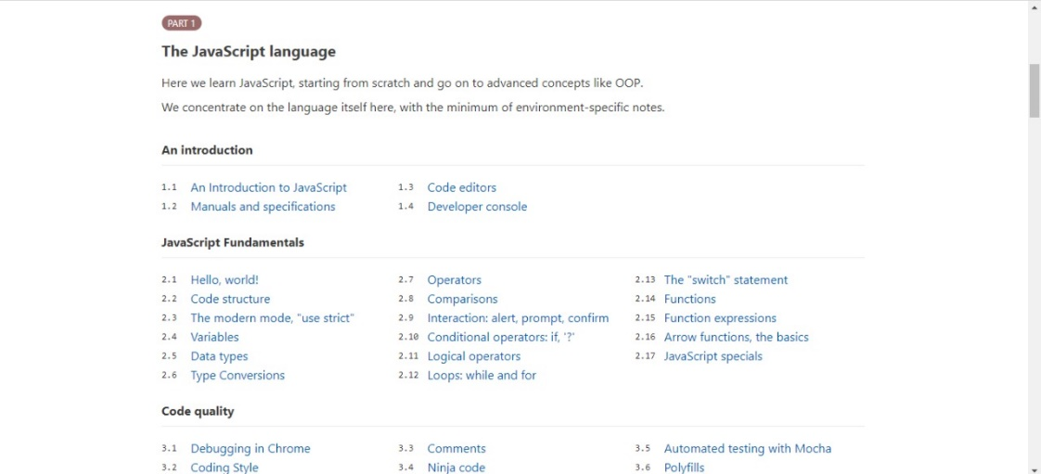

Tutorial for “HTML”:

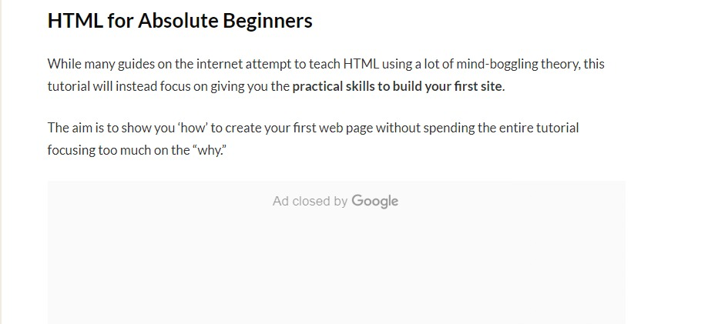

**ABOUT THE COMPILER:**

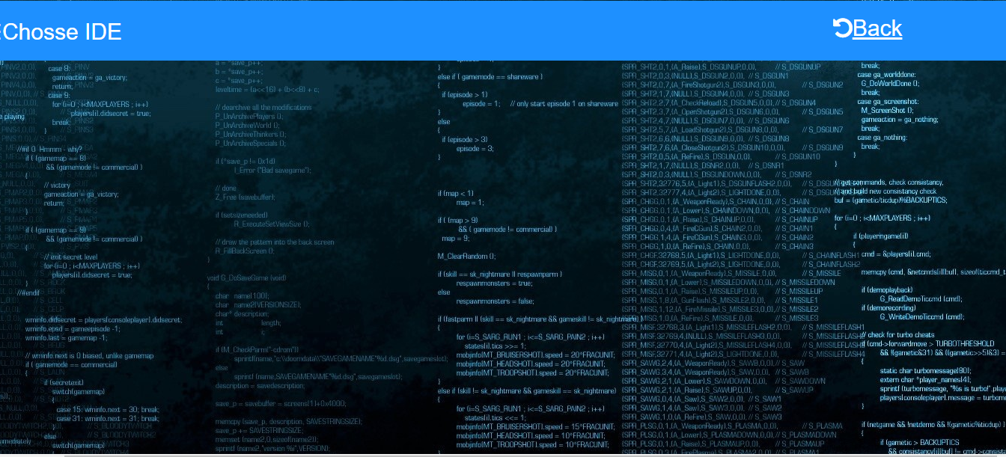

Users can choose their coding language/ide , by clicking on navigation bar.

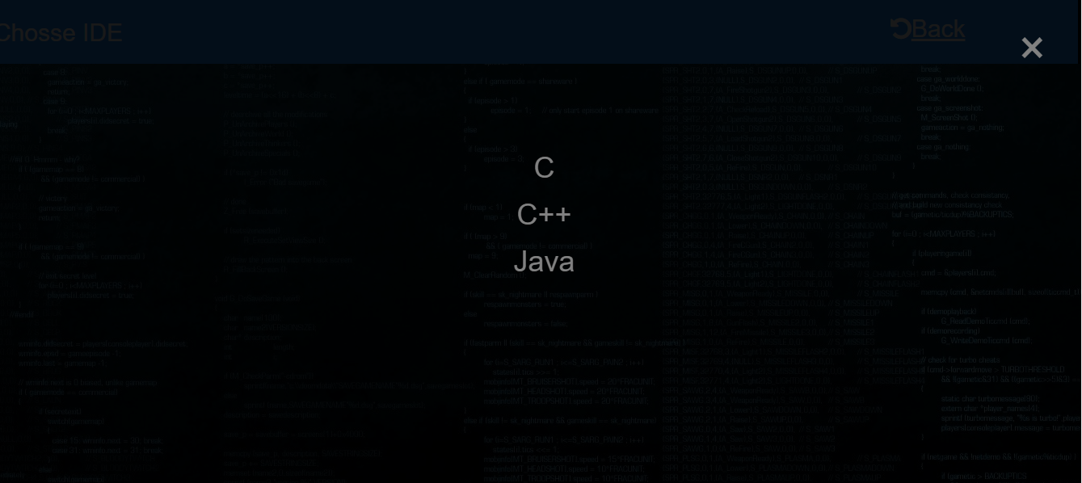

Users can choose their coding language/ide , by clicking on given options.

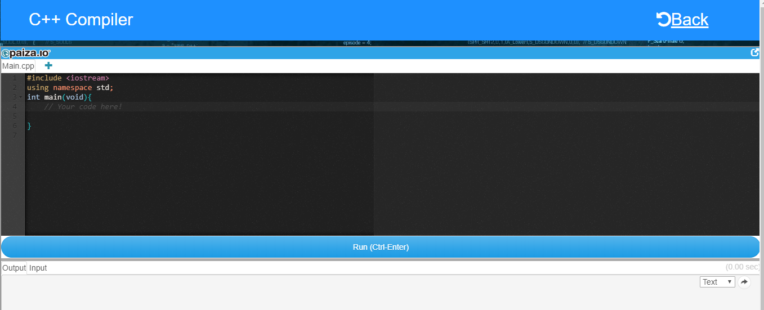

*(c++ compiler)*

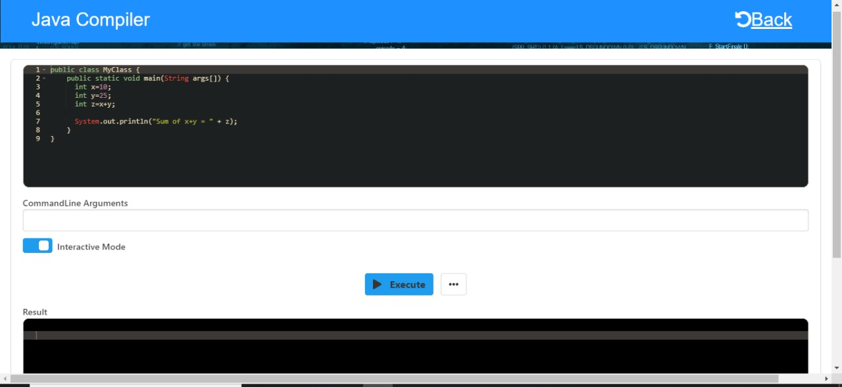

*(JAVA compiler)*

Users can enter their codes and execute them, just below the compiler screen there is output box where you can see what’s happening with the code. For each language there is a separate compiler which makes the coding platform user friendly.

**LOGIN & REGISTER INFORMATION:**

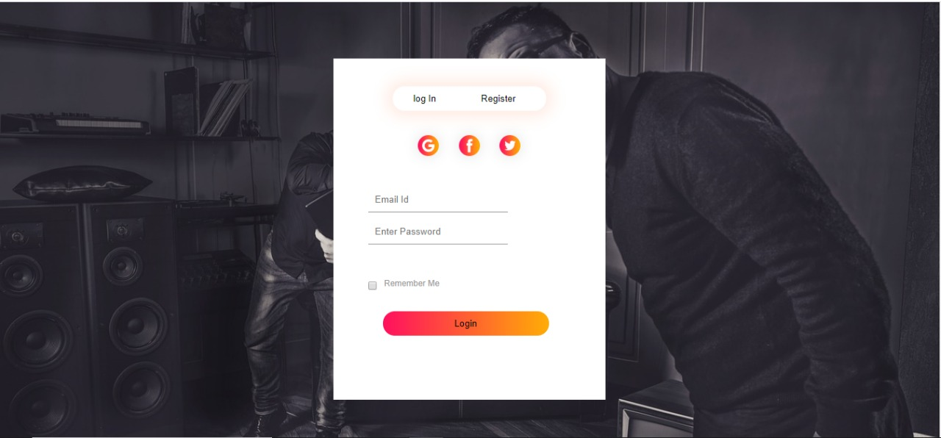

When use clicks on the login button from landing page, this type of login will open. It requires email id and password for login. If any use wants to register, they can register manually by clicking on register button and providing required details or they can also use g-mail, Facebook and twitter accounts.

IN CASE OF ANY QUERY:

If use is facing any problem or having any kind of query, they can directly ask to developer. It’s a simple two-step process, (I) click on the button provided as “contact us”, (II) enter your query/doubt, name and email address and “send”. It will look like:

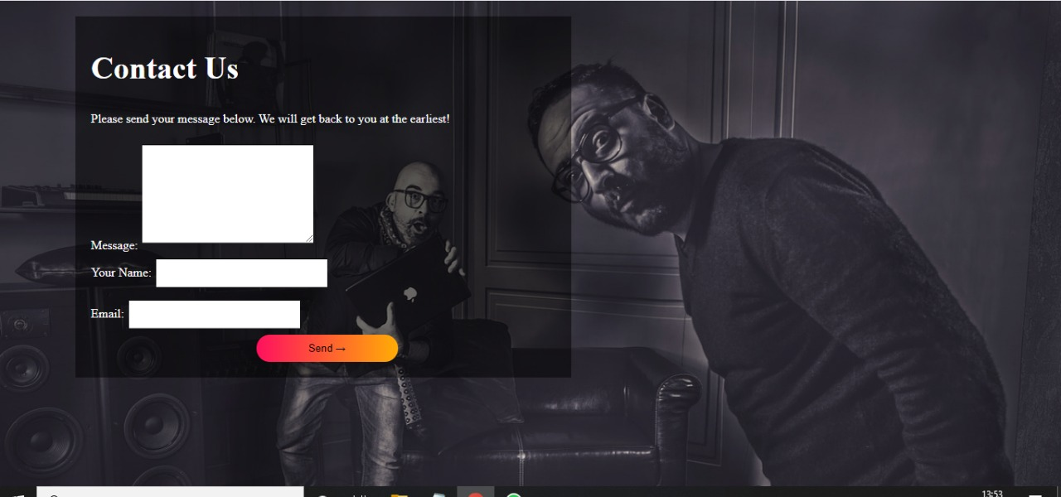

ABOUT THE DEVELOPERS:



User can also read about the developers, as name, occupation, qualification and mail address is visible to all with photograph for the convenience of user. And users can directly contact them.

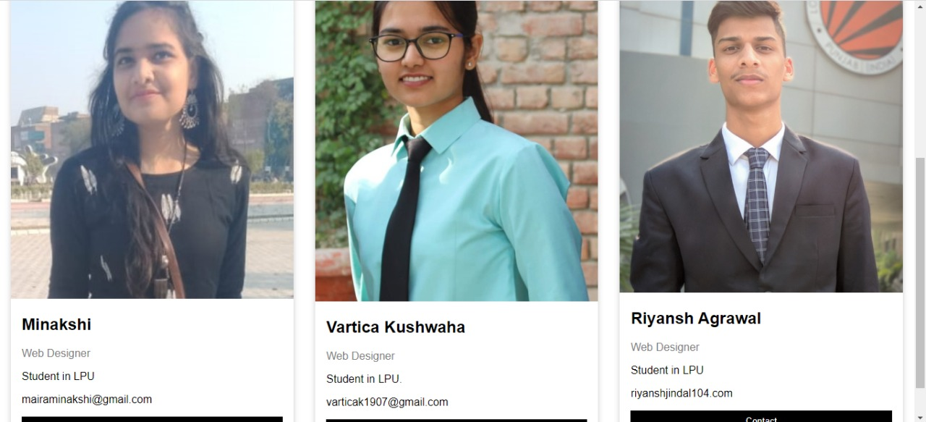

OUR WORDS FOR YOU: *“We are bunch of professionals from almost each corner of India, educated from same institutes, with technical backgrounds, and with lot of other non-commonalities but we have a common thing which is that we all are striving hard to bring the highest quality tutorials for our lovely readers”.*

**TECHNOLOGIES AND FRAMEWORK USED**

**Different phases of the project require different tools and technologies to be used and here is the project profile.**

* Browser used: Google Chrome
* HTML (Hypertext markup language) is has been used to structure the web page and CSS (Cascading style sheets) has been used to style different web pages.
* Programming Language: It is used to add functionality to website so that user can feel the scenario.
* Protocols are standardized instructions and this website.
* Platforms used: Notepad, Google Chrome, MS Word.

